Paper Title
Your name(s) [please omit titles, prefixes, etc.]
Your organisation
Optional abbreviated location (e.g. London, UK)
[If you want to add a full address, email, etc, use a footnote]
Abstract This document provides and defines the Word template for papers to be published in the proceedings of the Safety-critical Systems Symposium 2026 to be submitted by 30th September 2025. It also defines how and when you should submit your paper for publication. Please follow this template and the advice it contains as closely as possible, as this will help to ensure a consistent appearance for all papers published in the proceedings volume. If you do run into difficulties using the template, please contact me at mike.parsons@scsc.uk

1 Introduction
Please use UK English throughout. This includes spellings and also punctuation style (for example, in “quotes”, questions (single ‘?’) and exclamations (single ‘!’). Please also use the UK English style for abbreviations as in “e.g.” (not “e.g.,” as in US English).

3.1 Title
Please try and keep the title to a reasonable length; shorter titles are more memorable. It is often easier to use “Short Title: Subtitle” rather than one long title. If the title extends over more than one line, break it at a sensible point for example: “Experiences of avionics safety certification of an ARINC 653 RTOS on multi-core processor architecture” would be split as:

“Experiences of avionics safety certification
of an ARINC 653 RTOS
on multi-core processor architecture”

Better still might be a title:subtitle approach so:

“Avionics safety certification experiences:
ARINC 653 RTOS on multi-processor architecture”

3.2 Paragraphs
The first paragraph after a heading, figure, table, bulleted list, etc. is not indented, just as this paragraph has not been indented.
The second and subsequent paragraphs are indented; this paragraph provides an example of how this will appear on the page.

2 Length and structure of your paper
Typically, papers should be between 2,000 and 6,000 words in length, or 8-20 formatted pages. This is not a mandate; content is more important than length.
Structure your paper into numbered sections, using subsections and sub-subsections as seems appropriate – but please avoid going to sub-sub-subsections.
Keep cross-references to a minimum; when you do use a cross-reference, it should be to a section number, not a page number.
It is often helpful to include tables, pictures and diagrams to break up longer sections of text.

3 Page Orientation and Layout

3.1 Pages
Please keep all pages to Portrait orientation; this is because of book printing constraints. If you have a diagram or table which is best presented in landscape format then please rotate it within a portrait page.

3.2 Blank Lines
Generally there should be no blank lines between paragraphs within the same section, unless there is a sub-heading. However blank lines can be useful around quotes, diagrams, equations or other changes in the text.

3.3 Page Size
It is very important to keep to the defined page size as per this template as this is size of the finished page in the book. Please do not submit a Word file using any other page size (e.g. A4 or Letter) as this causes problems when all the Word files are combined.

4 Fonts and styles
This section defines the fonts and styles you should use in your paper.

4.1 Fonts
Normally, you should use the Times New Roman font, using font sizes as in this template. For special characters, use the Symbol font. To distinguish such things as the literal text of computer programs, use the Arial font, or Courier if you need a font in which every character has the same width. For emphasis, use italics. Italics should also be used for mathematical variables. Excerpts from other documents can use different fonts.

4.2 Styles
To help you prepare your text, the following styles have been defined:
- Title
- Author
- Affiliation
- Location
- Abstract
- No indent
- Indented paragraph
- Heading 1
- Heading 2
- Heading 3
- Run-in
- List bullet
- List bullet 2
- List number
- Footnote reference
- Footnote text
- Equation
- Figure
- Figure caption
- Table caption
- Table
- Quotation
- Acknowledgements
- References
- Footer
- Header
Examples of all of these styles can be found within this document.

5 Other formatting guidance
Strive for consistency in your use of names, terms and abbreviations. Define each abbreviation the first time you use it, and use only the abbreviated form thereafter. There is no need to include a separate list of abbreviations.
Run-ins. Use a run-in heading (as used here) if you wish to give a paragraph a title without introducing additional numbered headings.

5.1 References
Cite references using the author name(s) and year of publication in parentheses:
- one author: (Smith 2011)
- two authors: (Smith and Jones 2012)
- three or more authors: (Smith et al. 2013).
Include each of the cited references in a list at the end of your paper, giving sufficient detail to enable readers to track down the reference. As a minimum, include the author, year of publication and title. For a journal article, also give the name of the journal, with volume and page numbers. For a book, name the publisher. For a paper published in a book, give details of both the paper and the book, including the editor(s) of the book, its title and its publisher. If you refer to an online document, include its full address (i.e. http://...), check that it is still accessible, and give the date you made the check (e.g. Accessed 7th Aug 2025).
List only those references that you have referred to within your paper, arranging them in alphabetical order, by first author. The list at the end of this document (Alexander et al. 1977, Armoush et al. 2009, Pierce and Fowler 2010, RAEng 2011) is provided to give a few examples for you to follow.

5.2 Equations
Simple equations like a² + b² = c² can be written as normal text. For more complex equations, use MathType or the Microsoft equation editor, inserting the resulting graphic as an object.
Number equations only if you need to refer back to them. If you do number them, put the number in parentheses, right justified, as in the example below.
(1)

5.3 Figures and Images
Please include all charts, diagrams or pictures in your paper in colour where available, the book and online PDFs will use colour.

5.3.1 Copyright of images
Please check the copyright status of all images or diagrams you include, especially those obtained from internet searches. You should always try to obtain the explicit permission from the copyright holder, and state the source and conditions in the Figure legend.
Alternatively it is often easier to source images from public domain sources or from Wikimedia Commons. In addition the SCSC has paid access to commercial image libraries and often we can source an alternative image if you get stuck.

5.3.1 Figure captions
Captions should appear below figures, as shown in Figure 1.
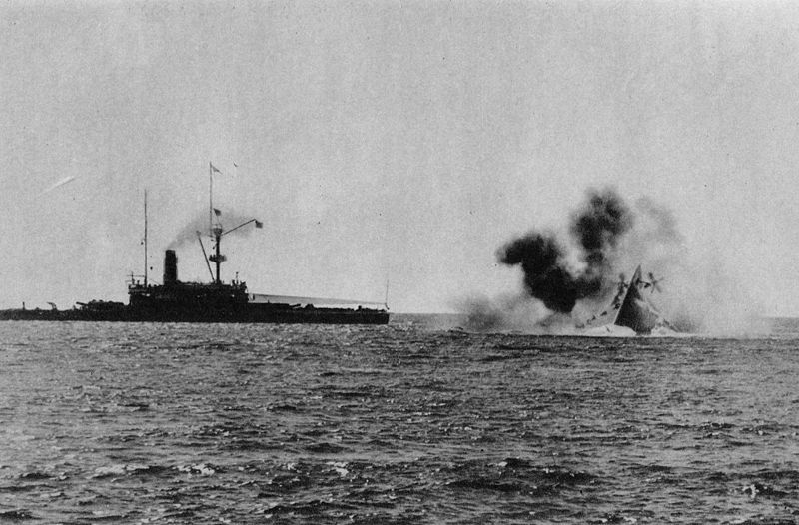
Fig. 1. Loss of HMS Victoria

5.3.2 Size and position
Figures should appear as soon as possible after they are first referred to. Usually, this will be either immediately below the paragraph referring to them, or near the top of the next page.
Figures must fit within the margins, and should be centred on the page. Make sure that the figure is clear, and that any text is big enough to be legible in book format. If in doubt, print it out and check what it looks like on paper.

5.4 Tables
Tables should be centred and laid out as in the example below (see Table 1), adding columns and rows as necessary. Columns should be left-justified or centred, depending on the type of contents. Table captions appear before tables. Avoid splitting tables across pages, and make sure they fit within the margins.
Table 1. Survey results: architectural pattern use
Safety Pattern Name | Count
Monitor Actuator | 1
Sanity Check | 4
Fault Diagnosis, Isolation and Recovery | 1
Data Integrity Sampling | 6

5.5 Quotations
Short direct quotations can be included in the text, using ‘single quotation marks’. Longer quotations should be formatted as shown in the following example:
‘To perform their professional functions, safety engineering professionals must have education, training and experience in a common body of knowledge. They need to have a fundamental knowledge of physics, chemistry, biology, physiology, statistics, mathematics, computer science, engineering mechanics, industrial processes, business, communication and psychology.’

6 Using material already published
If you find it necessary to include somebody else’s copyright material in your paper, you must obtain permission for its use. This should be made explicit in your paper (e.g. by including ‘By kind permission of…’ in a footnote). See also the note about images earlier.

7 Submitting your paper to the editor
When you feel your paper is ready to be published, arrange for a peer check by your colleagues, then email it as a Word document to mike.parsons@scsc.uk Please do this no later than 30th September 2025. If you find that you are struggling to meet this deadline, please contact me without delay.

Any content you submit to SCSC will be considered non-confidential and non-proprietary unless you contact us to notify us otherwise. You retain all of your ownership rights in your content, but you are required to grant us and any readers of your content a limited licence to use, store and copy that content and to distribute and make it available to third parties.

We also have the right to disclose your identity to any third party who is claiming that any content posted or uploaded by you to our site constitutes a violation of their intellectual property rights, or of their right to privacy.

8 Publication
Your paper will be published as part of the proceedings volume, which will be available free of charge to delegates attending the Symposium. This time the Symposium takes place in February 2026 in York, UK. You or one of your co-authors will need to present the paper at this event. In agreeing to prepare the paper you are also making a commitment to its presentation, for without this there could be no Symposium. You will have about 25 minutes for your presentation, and 5 minutes for questions.
We very much hope that you will be able to attend for the entire event and participate in the discussions that will take place throughout, both formal and informal.
The proceedings volume will be published by the Safety-Critical Systems Club, and will be available in hardcopy from Amazon. The book will have an ISBN number, and will be available for purchase through the Amazon website. Individual papers will be accessible from the Safety-Critical Systems Club’s website www.scsc.uk.

In order to publish your article, we need your agreement in writing. Please take a moment to read the terms of this license, sign the form and return it to us as quickly as possible.

………………………..

Instructions for Completing the
SCSC License to Publish Form
The form may be printed out and filled in manually, but please write clearly
Note when printing that either A4 or Letter size paper may be used. If your printer is single sided only, set so as just to print Page 2.
In all cases, the Title and Author(s) name(s) are required. If an organization holds the copyright, its name and postal address is also required.
When complete, and if not already done, print out a copy of the form for signature.
If the copyright owner is an organization, a representative must sign the form, thus:
<signature of representative
<name of representative>, on behalf of <name of organisation> <date of signature>
Alternatively, if the Author(s) retain(s) the copyright, each is to sign the form:
<signature of Author> <date of signature>

When the form is complete and signed, please scan it and send it by e-mail to the SCSC editor who sent you the form to complete, retaining the master for your records. If a scanner is not available, a sufficiently high-resolution photograph would suffice.

Title of Article: _______________________________________________________
Name of Author(s): _______________________________________________________
Name & Address of Copyright Owner (if not author): _______________________________
_______________________________________________________
- Safety-Critical Systems Club and SCSC are trading names of the Safety-Critical Systems Club C.I.C. a Community Interest Company limited by guarantee and registered in England and Wales with company number 13084663. Registered Office: Southgate Chambers, 37/39 Southgate Street, Winchester, SO23 9EH.
- By signing this form, you (the copyright owner or authorized representative of the owner):
  - Agree to grant to the Safety-Critical Systems Club (the publisher) the non-exclusive right to publish, distribute or broadcast your paper in printed or digital form, e.g. in the SCSC Newsletter, the SCSC eJournal, SCSC books, and online through our website.
  - Assert that the paper is your original work. If it contains material which is someone else’s copyright, you assert that you have obtained the unrestricted permission of the copyright owner, and that the material is clearly identified and acknowledged in the text.
  - Assert that the paper does not, to the best of your knowledge, contain anything which is libelous, illegal or infringes anyone’s copyright or other rights, and that appropriate releases have been obtained from people identifiable in any images included.
  - Assert your Moral Rights to be identified as the author, if appropriate.
- We confirm that we will respect the rights of the author(s) and will make sure that their name(s) are always closely associated with the paper.
- Copyright remains with the copyright owner(s) and we will acknowledge this. However, you authorize the Safety Critical Systems Club, if we wish, to act on your behalf to defend copyright.

Signatures:

…………………………………..

If you foresee any problem with entering into this agreement, please contact me without delay.
You should insert your own copyright details in the page 1 footnote of your paper; this will normally name you or your employer as the owner of the copyright.
Acknowledgments Any acknowledgments should appear at the end of the paper, before the reference list. It is usual to acknowledge significant contributors or reviewers.
Disclaimers Any disclaimers should be presented at the end in this format.
References

Alexander C, Ishikawa S, Silverstein M et al (1977) A pattern language: towns, buildings, construction. Oxford University Press
Armoush A, Salewski F, Kowalewski S (2009) Design pattern representation for safety-critical embedded systems. J Softw Eng Appl 2:1-12
Pierce R, Fowler D (2010) Applying IEC 61508 to air traffic management. In: Dale C, Anderson T (eds) Making systems safer. Springer
RAEng (2011) Global navigation space systems: reliance and vulnerabilities. Royal Academy of Engineering. http://www.raeng.org.uk/gnss. Accessed 31 August 2011

